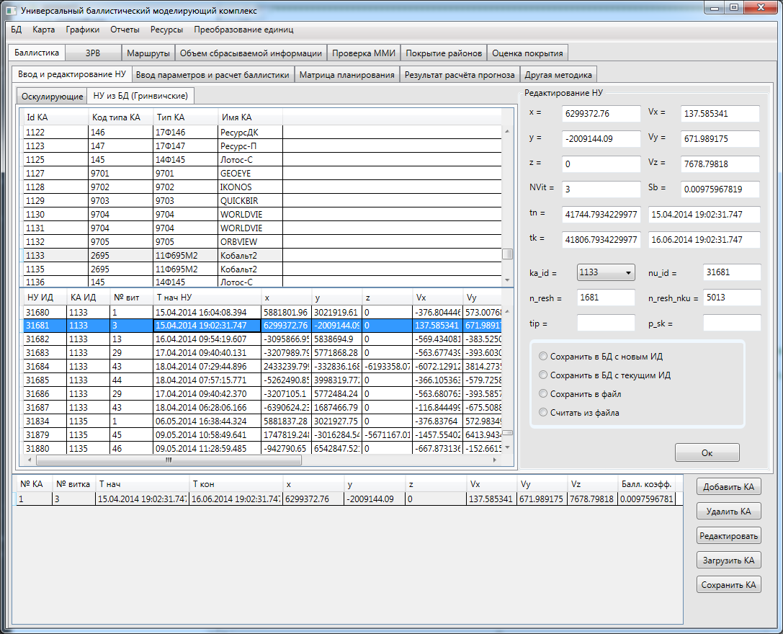

|  |  |  |  |  |  |  |  |  |  |  |
| --- | --- | --- | --- | --- | --- | --- | --- | --- | --- | --- |
| 1 | 3 | 15.04.2014 19:02:31.747 | 16.06.2014 19:02:31.747 | 6299372.76 | -2009144.09 | 0 | 137.585341 | 671.989175 | 7678.79818 | 0.00975967819 |

Ka_id 1133 **nu_id 31681** n_resh 1681 n_resh_nku 5013